# Justification for Design :

These web pages are made to showcase simple text and some pictures. I tried to design it in a way that reader find it appealing, simple and attractive. Here are my thoughts about making this design:

* I make it simple and sleek and added different colors in all web pages to make it cool and interesting as it contains only text and few of pictures.
* I put different paragraphs in different containers with changed background so that text can be differentiated and readable.
* The navigation bar is simply containing links to different pages and have colorful border at bottom.

Overall, I think this design is colorful, attractive and presents text and images simply and beautifully.

Screens :

1. 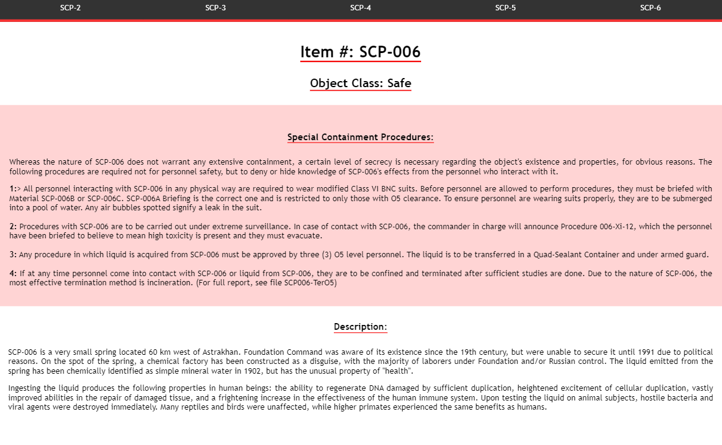Laptop
2. 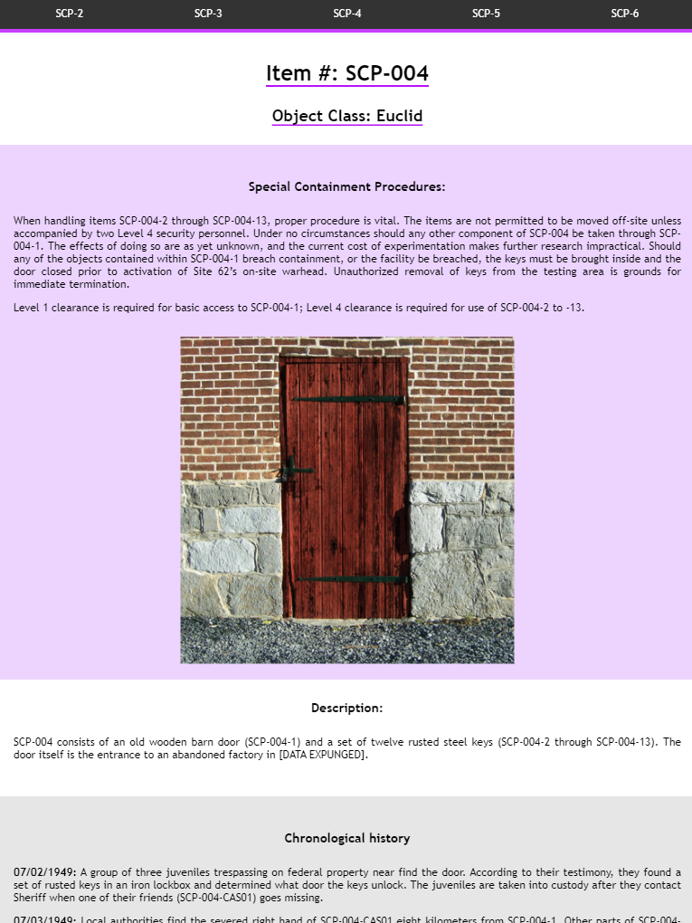Ipad pro
3. Iphone X

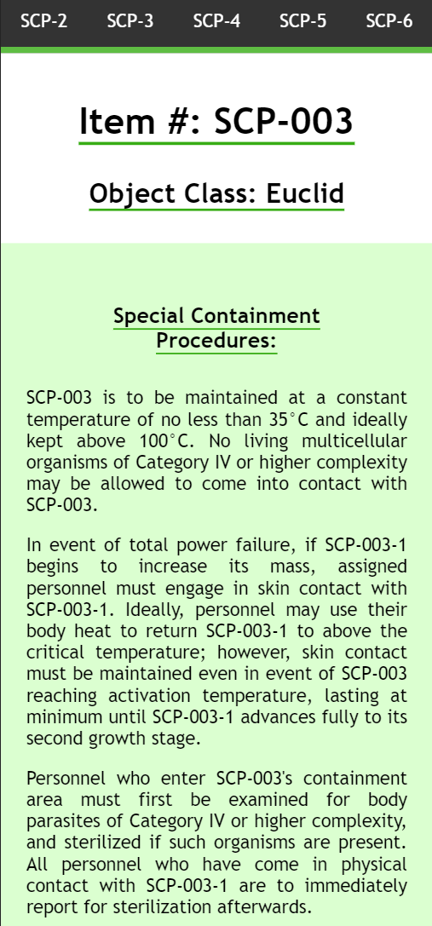

1. Chuwi Hi 12

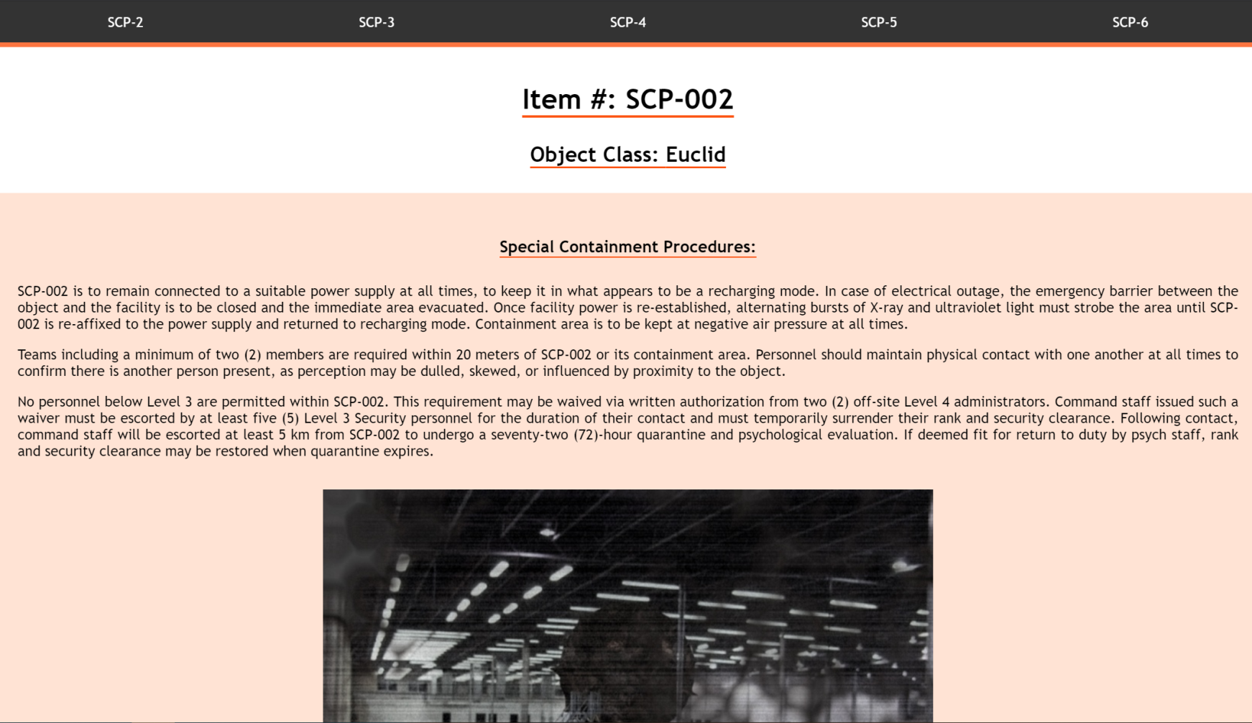

1. Pixel 2

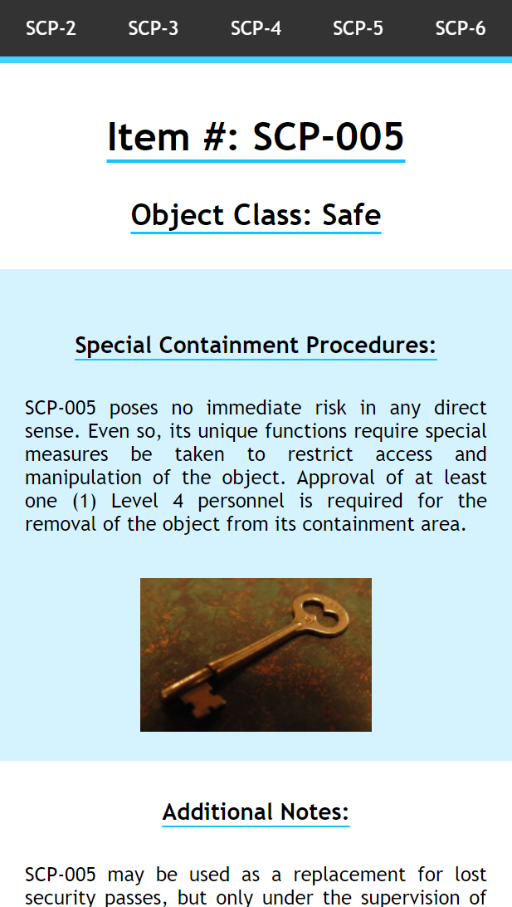

HTML validation :

1. SCP_004

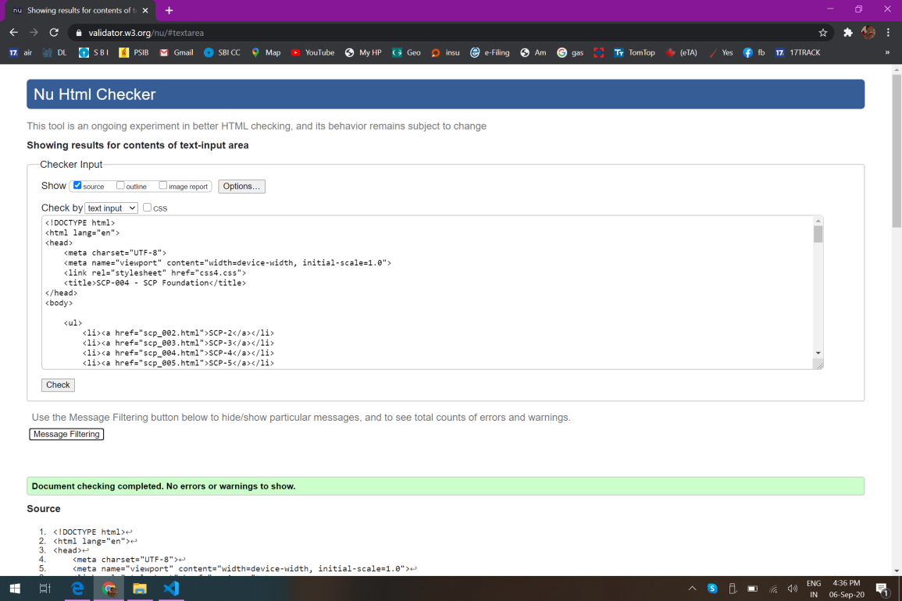

1. SCP_003

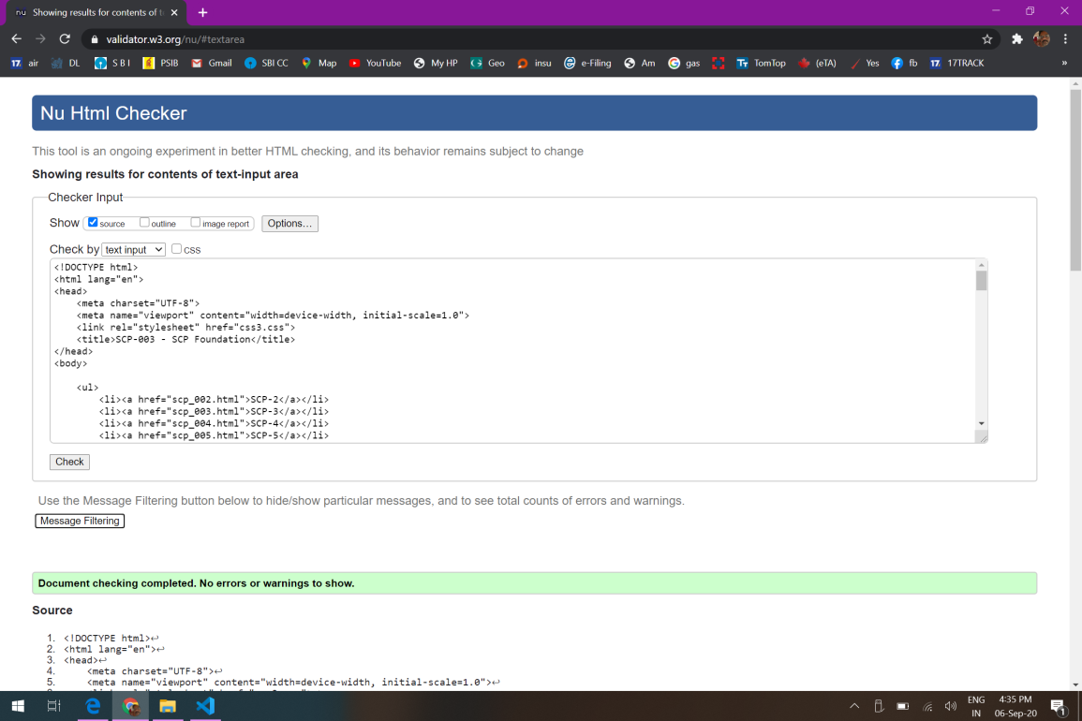

1. SCP_002

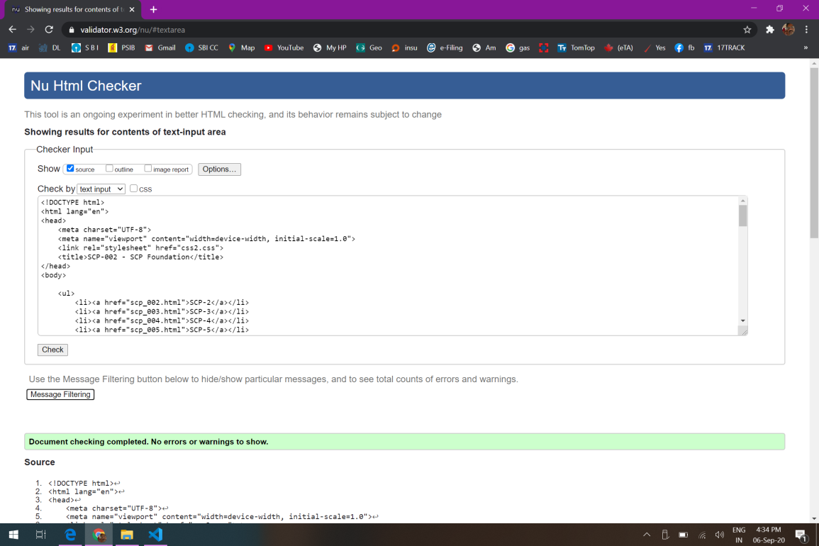

1. SCP_5

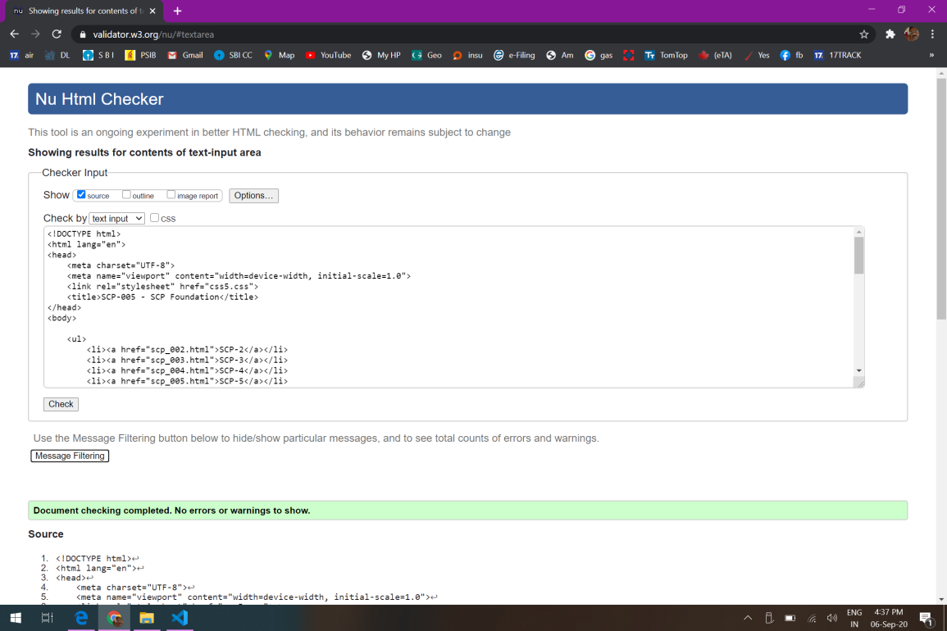

1. SCP_006

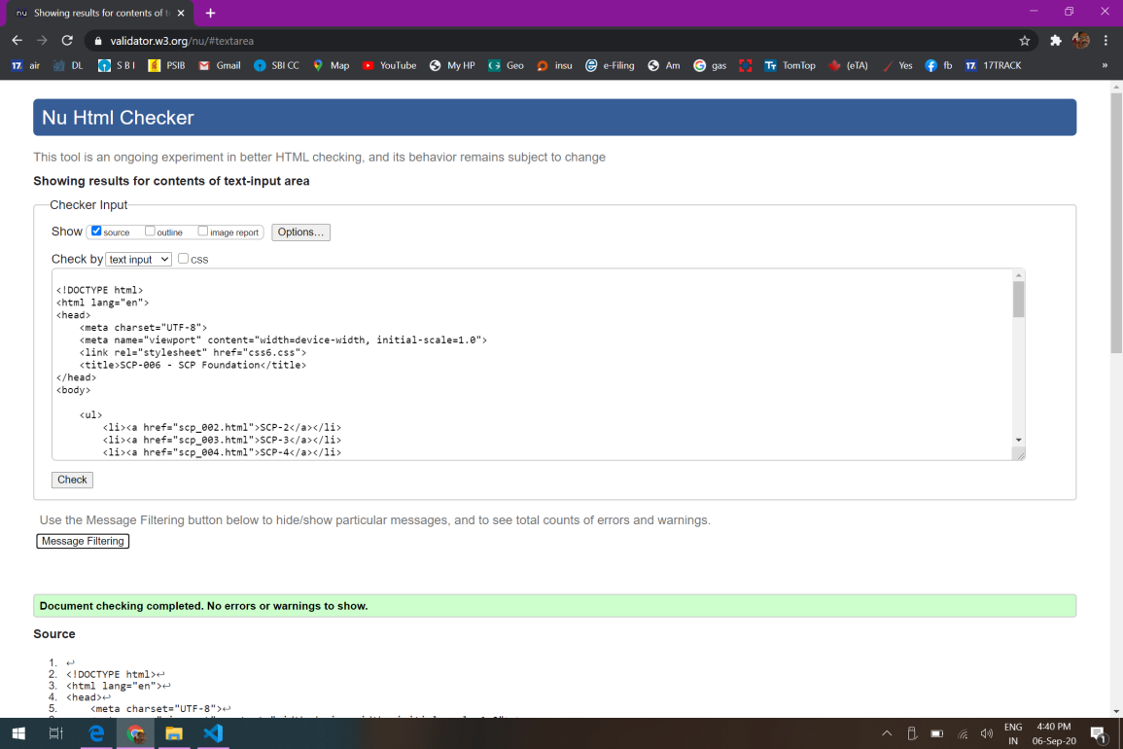

CSS validation :

1. CSS-002

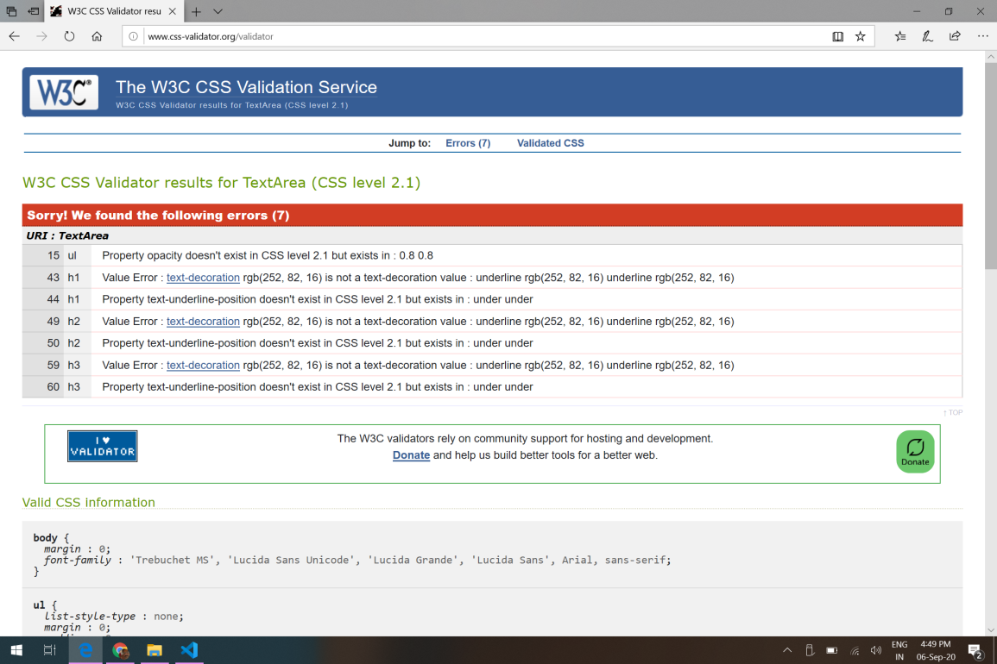

1. CSS-003

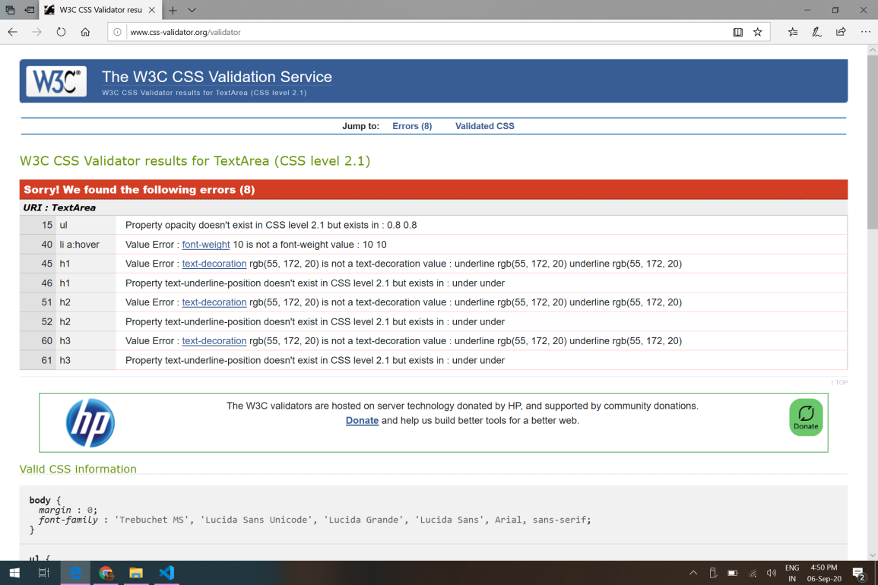

1. CSS-4

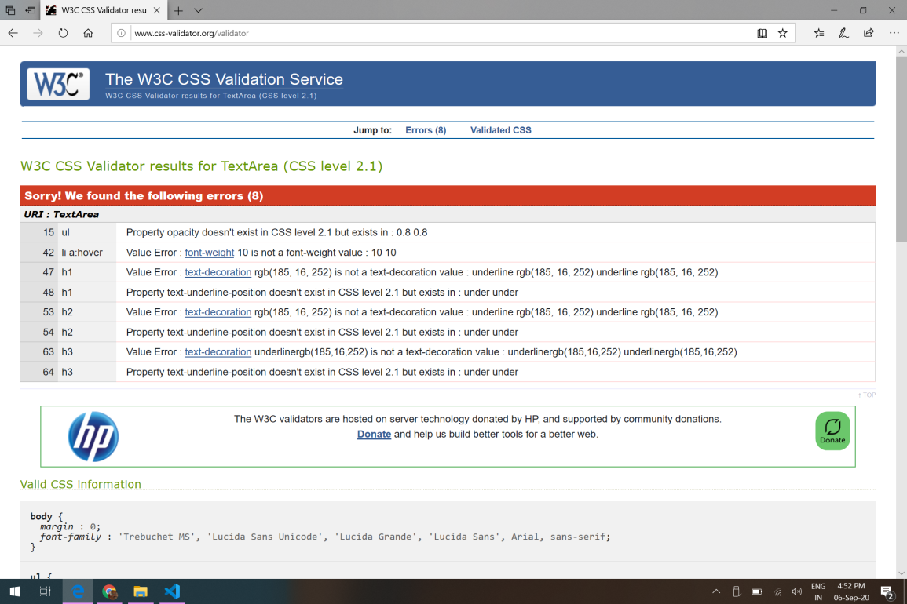

1. CSS-5

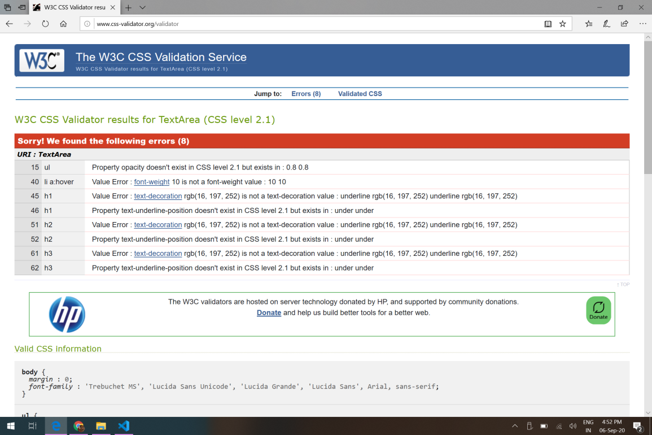

1. CSS-6

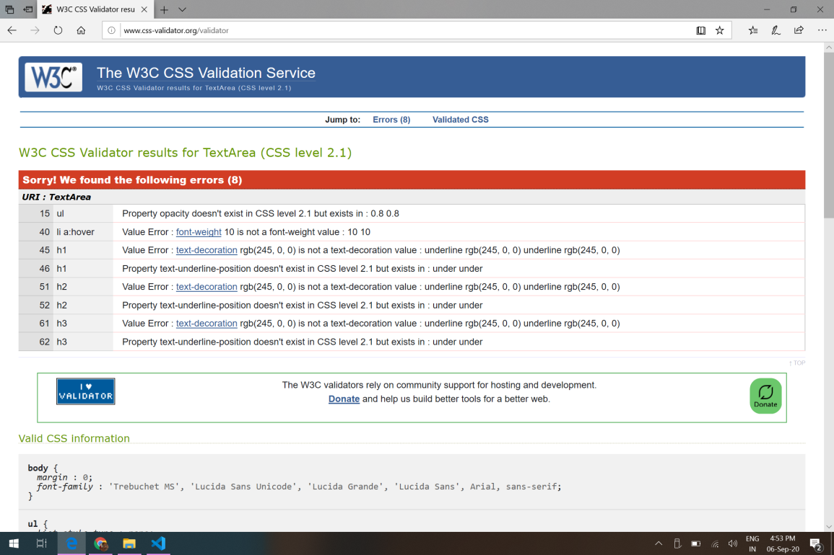

GITHUB LINK - <https://github.com/Daman30028646/30028646_Damanpreet-Singh.git>

USERNAME – a30028646

PASSWORD – Toiohomai1234

Cpanel - <https://30028646.2020.labnet.nz/scp2/>